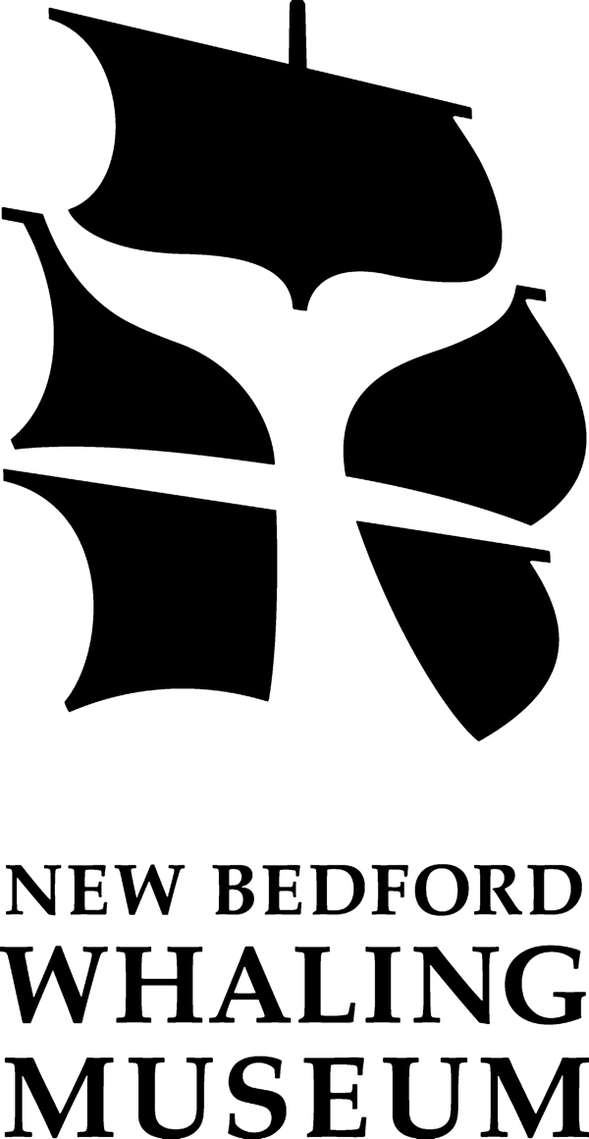
NBWM High School Apprenticeship Program 2013-2014
Application Form

Name ________________________________________________________________________
Address ______________________________________________________________________
Date of Birth ____________________ City of Birth ________________________________
Phone # ___________________________ Cell # ____________________________________
Email _____________________________________ Receiving free or reduced lunch _____
Grade _______ School __________________ Year of Graduation _________________
-----------------------------------------------------------------------------------------------------------------------
(please use the back of this sheet if you need more space for your answers)

Why do you want to participate in the NBWM apprenticeship program?

What is your past experience with the New Bedford Whaling Museum?

What holds a greater interest for you, history, science or arts? Why?

What science topics do you enjoy the most? (examples include cetaceans, biology, geology, insects, fossils, physics, chemistry, currents, food webs, botany, comparative anatomy, skeletons, medicine…)

If I could design my own exhibit, it would be about ____ because ________.

Can you commit to the time necessary to complete this apprentice program?

Please list any organizations or clubs at school of which you are a member.
Please state the years you were involved and your position within that club –– member, vice president, president, secretary, etc.

Please provide us with the names and contact information for two references, and a copy of your most recent report card.

