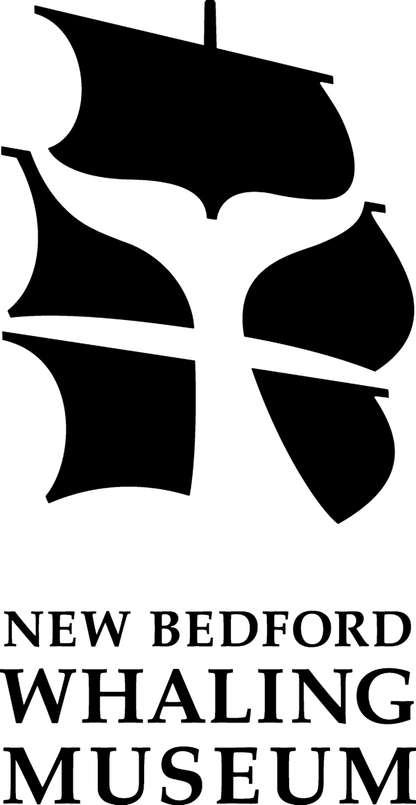
New Bedford Whaling Museum High School Apprentice Program 2013-14

The New Bedford Whaling Museum Apprenticeship program offers an opportunity to high school students who excel academically and express interest in gaining work and college readiness experience while earning a competitive wage. The Apprenticeship program will use museum resources as well as those of regional academic and scientific institutions to increase the knowledge base and practical experiences of high school students in New Bedford while encouraging them to continue their studies with the goal of entering college.

Over the length of an academic year, and the summer that follows, apprentices will gain a basic understanding of the work of the different departments and will leave the program with an understanding of how a museum functions both in front of and behind the scenes. We will visit other facilities and experience their exhibits and teen programming. You will also become well versed in cetacean biology and learn about fisheries and local coastal issues.

During the course of the program teens will meet and learn from a variety of experts, participate in hands-on projects and assist with Museum events. Just as importantly, students will also develop organizing, problem solving, and team-building skills. They will also be encouraged to think creatively, develop presentation, storytelling and public interaction skills, and learn how to think on their feet in front of an audience.

Students will be encouraged to write articles about their apprenticeship for their school newspaper, and will contribute to their own Museum blog site. Their writings will also be considered for inclusion into The Bulletin from Johnny Cake Hill, the Museum’s journal for its membership. Apprentices will be expected to create a personal journal that will allow them the opportunity to track their learning over the course of the program and reflect on their experiences as they happen. Ultimately, students will exit the program much more aware of their city’s critical role in US history, and as ocean literate citizens, fully cognizant of how ‘the ocean and humans are inextricably interconnected’.

The program takes place during two sessions during the academic year and one summer session. The school year sessions will run from October – January and February – May. Students will work from 3:00 – 5:00 pm during these sessions, Tuesday - Friday. The summer session runs for six weeks in July and August. Students work from 10:00 am – 4:00 pm, Monday - Thursday.

Applications are being accepted throughout the summer. Interested students should fill out an application form and return it, and a copy of the most recent report card, by Wed., Sept 27, to:
Robert Rocha, Science Director, New Bedford Whaling Museum, 18 Johnny Cake Hill, New Bedford, MA 02740, or to the
Dean of Students / Co-op Coordinator / Internship Coordinator at your school

Applications are available at www.whalingmuseum.org/learn/opportunities, at your school and at the front desk of the New Bedford Whaling Museum.

For further information contact Mr. Rocha, (508) 717-6849 or rrocha@whalingmuseum.org

